Olive Medical Practice and Hollins Grove Surgery
Zero Tolerance Practice Policy
Document type | Policy
Document Title | Zero Tolerance Practice Policy
Prepared by | Local Primary Care Federation
Implemented by | Donna Middleton
Version | 1.0
Effective from | 18.09.2019 Reviewed – 03.09.2020
Review date | 03.09.2021

Version | Date | Amendments
1.0 | 18.09.2019 | Policy Implemented- This is a new policy for both Hollins Grove Surgery and Olive Medical Practice.

INTRODUCTION
The Practice takes it very seriously if a member of staff is treated in an abusive or violent way.

The Practice supports the government's 'Zero Tolerance' campaign for Health Service Staff. This states that GPs and their staff have a right to care for others without fear of being attacked or abused. To successfully provide these services a mutual respect between all the staff and patients has to be in place.

Our Practice staff aim to be polite, helpful, and sensitive to all patients’ individual needs and circumstances. They would respectfully remind patients that very often staff could be confronted with a multitude of varying and sometimes difficult tasks and situations, all at the same time. The staff understand that ill patients do not always act in a reasonable manner and will take this into consideration when trying to deal with a misunderstanding or complaint.

However, aggressive behaviour, be it violent or abusive, will not be tolerated and may result in you being removed from the Practice list and, in extreme cases, the Police being contacted.

In order for the practice to maintain good relations with their patients the practice would like to ask all its patients to read and take note of the occasional types of behaviour that would be found unacceptable:

- Using bad language or swearing at practice staff
- Any physical violence towards any member of the Primary Health Care Team or other patients, such as pushing or shoving
- Verbal abuse towards the staff in any form including verbally insulting the staff
- Racial abuse and sexual harassment will not be tolerated within this practice
- Persistent or unrealistic demands that cause stress to staff will not be accepted. Requests will be met wherever possible and explanations given when they cannot
- Causing damage/stealing from the Practice's premises, staff or patients
- Obtaining drugs and/or medical services fraudulently
- We ask you to treat your GPs and their staff courteously at all times.

The Legal Position

As a responsible employer, the Practice has a duty as a provider of NHS healthcare to protect the health, safety and welfare of staff under the Health & Safety at Work Act.

Staff members who are victims of violent conduct or assault have the right to sue their employers for compensation if the risk of violence could have been reduced or removed completely, but the employers did not act upon this information.

Examples of security issues:
- Security of grounds and car parking
- Security of premises – incl. storage, “out of hours”
- CCTV
- Cash and staff - storing, handling and transferring
- Security Systems
- Security of equipment – medical devices, computers
- Communication of national security alerts
- Information records
- Contingency planning.
- Security of employees
- Staff working on their own
- (Staff can be lone workers when making domiciliary visits or within a hospital department e.g. out of hours)

This list is not exhaustive.
Violence at Work

The practice acknowledges that there may be instances where violence and / or aggression forms part of a patient’s illness. In these circumstances, the issue will be discussed with the patient and form part of their care planning.

This information will be recorded in the patient’s medical record and flagged to ensure that members of staff are aware. In addition, where deemed necessary, appropriate support will be put in place, e.g. staff members do not see the patient alone.

Definition of Physical and Verbal Abuse and Violence:

Physical and verbal abuse includes:
- Unreasonable and / or offensive remarks or behaviour / rude gestures / innuendoes
- Sexual and racial harassment
- Threatening behaviour (with or without a weapon)
- Actual physical assault (whether or not it results in actual injury) includes being pushed or shoved as well as being hit, punched or attacked with a weapon, or being intentionally struck with bodily fluids or excrement.
- Attacks on partners, members of staff or the public
- Discrimination of any kind
- Damage to an employee's or employer's property

The Practice supports the Zero Tolerance stance adopted by the NHS.

The HSE (Health and Safety Executive) defines work-related violence as:
"Any incident, in which a person is abused, threatened or assaulted in circumstances relating to their work".

Violence and aggression towards a person may also be defined as:
"A physical contact with another person which may or may not result in pain or injury. The contact is uninvited and is an attempt to cause harm, injury or to intimidate. Non-physical aggression includes the use of language which causes offence or threatens the safety of a member of staff".

Under the Health and Safety at Work Act 1974, the practice will also undertake the following measures to ensure a safe work environment:

- Carry our risk assessments to assess and review the duties of employees, identifying any "at risk" situations and taking appropriate steps to reduce or remove the risk to employees, particularly if they are working alone.
- Assess and review the layout of the premises to reduce the risk to employees where physically possible.
- Assess and review the provision of personal safety equipment, such as alarms.
- Develop surgery policies, procedures and guidelines for dealing with physical and verbal abuse.
- Provide support and counselling for victims, or refer to suitably qualified health professionals.
- Make employees aware of risks and ensure employee involvement in suitable training courses.
- Record any incidents on a Significant Event form and take any remedial action to ensure similar incidents are prevented in future.

REMOVAL FROM THE PRACTICE LIST

The removal of patients from our list is an exceptional and rare event and is a last resort in an impaired patient-practice relationship. We value and respect good patient-doctor relationships based on mutual respect and trust. When trust has irretrievably broken down, the practice will consider all factors before removing a patient from their list, and communicate to them that it is in the patient’s best interest that they should find a new practice. An exception to this is in the case of immediate removal on the grounds of violence e.g. when the Police are involved.

Removing other members of the household

Because of the possible need to visit patients at home, it may be necessary to terminate responsibility for other members of the family or the entire household to ensure the safety of practice staff.

The prospect of visiting patients that is the residence of a relative who is no longer a patient of the practice, or the risk of being regularly confronted by the removed patient, may make it difficult for the practice to continue to look after the whole family. This is more likely where the removed patient has been violent or displayed threatening behaviour, and keeping the other family members could put doctors or their staff at risk.

Zero Tolerance Poster

Zero Tolerance Posters have been made available from CCGs for use in practices and NHS healthcare providers premises.

The poster on the following page can be used and resized in another template or a blank page and displayed in practice.
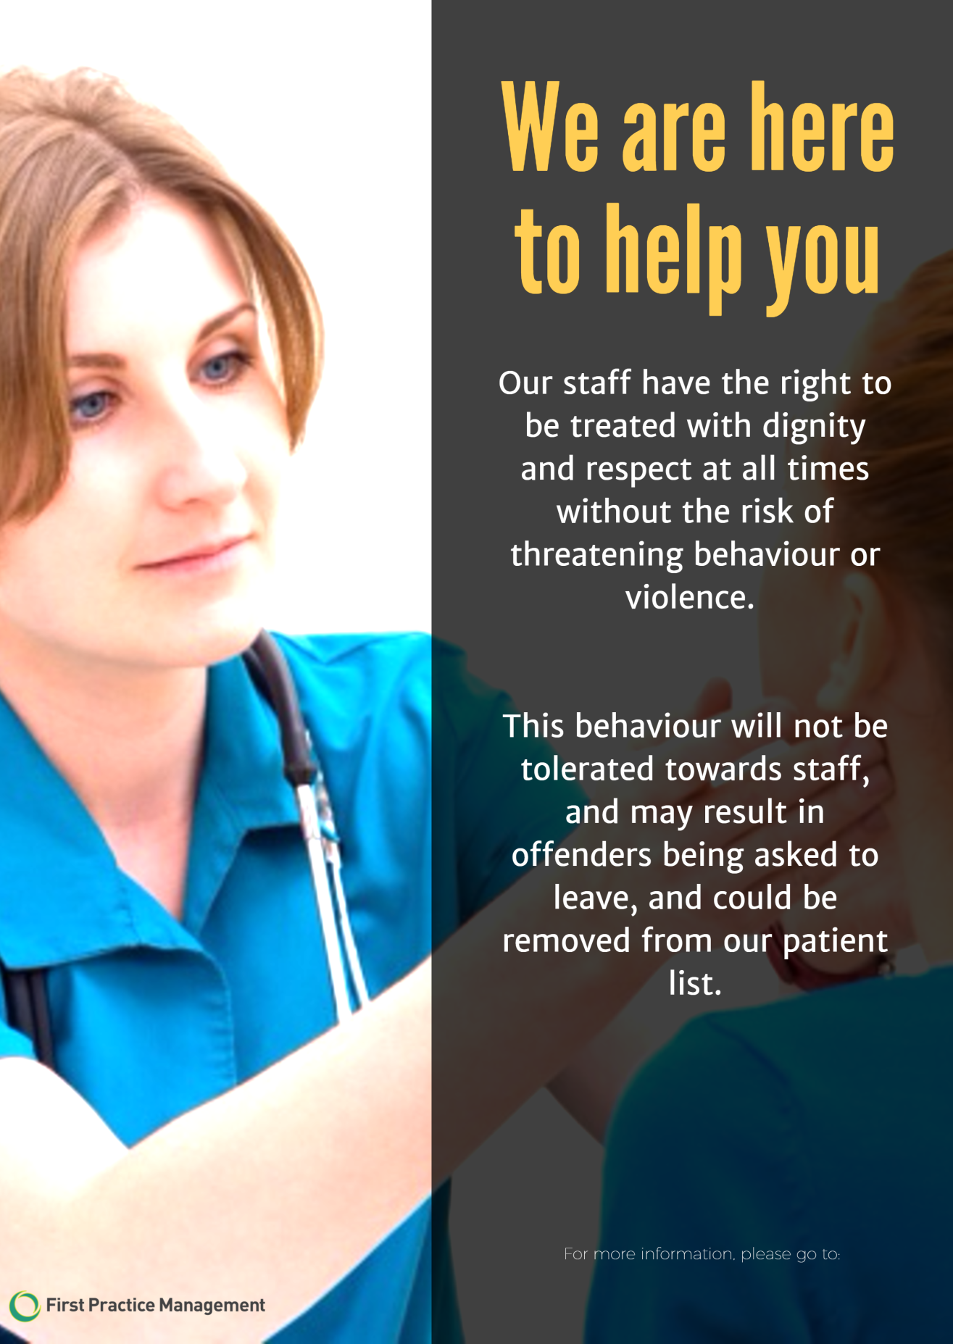
Olive Medical Practice and Hollins Grove Surgery

